**Project Design Phase-II**

**Data Flow Diagram & User Stories**

| Date | 26-05-2025 |
| --- | --- |
| Team ID | LTVIP2025TMID55721 |
| Project Name | ShopEZ:ONE-STOP SHOP FOR ONLINE PURCHASES |
| Maximum Marks | 4 Marks |

**Data Flow Diagrams:**

A Data Flow Diagram (DFD) illustrates how data moves within the **ShopEZ** platform. It captures how users interact with the system, how information flows between different components, and where the data is stored.

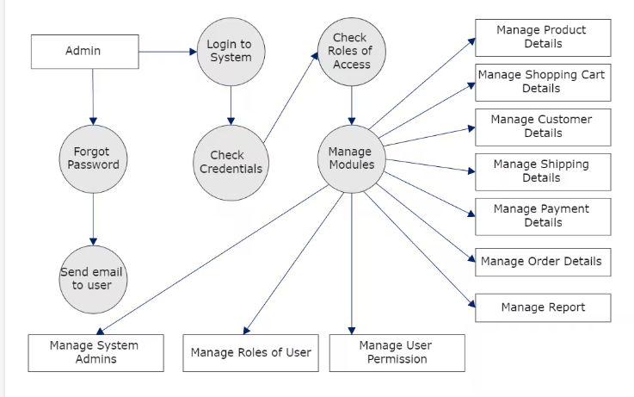

| **User Type** | **Functional Requirement (Epic)** | **User Story / Task** | **Acceptance Criteria** | **Priority** | **Release** |
| --- | --- | --- | --- | --- | --- |
| **Customer** | Product Search & Purchase | As a customer, I can search for and purchase products. | Product appears in cart and order is placed. | High | Sprint-1 |
| **Seller** | Product Management | As a seller, I can list and manage products. | Products listed appear on customer dashboard. | High | Sprint-1 |
| **Customer** | Order Tracking | As a customer, I can track the status of my order in real-time. | Order status updates are shown on the order page. | Medium | Sprint-2 |
| **Customer** | Payment Processing | As a customer, I can pay securely using multiple options. | Payment confirmation is sent to user and seller. | High | Sprint-2 |
| **Admin** | Platform Moderation | As an admin, I can manage sellers, products, and reports. | Actions are logged and visible in admin dashboard. | High | Sprint-1 |